STEVE JOBS 2015

Film Workbook and Keynote Challenge

English for IT Students
Name: Miguel
Class: 1º DAW Date: 30-09-2026
Your viewing route
- Part 1 — Macintosh, 1984: Questions 1–12.
- Part 2 — NeXT, 1988: Questions 13–23.
- Part 3 — iMac, 1998: Questions 24–35.
Useful words
- Launch: introduce a new product.
- Backstage: behind the stage.
- Engineer: someone who designs or builds technology.
- Feature: something a product has or can do.
- Prototype: an early version used for testing.
- Keynote: the main presentation at an event.

PART 1 — MACINTOSH, 1984
1. Which product is Steve preparing to launch in 1984?
A) The Apple Watch
B) The Macintosh
C) The iPad
D) The iPhone
2. What goes wrong with the voice demo?
A) The computer cannot say “Hello”.
B) The keyboard is missing.
C) The screen is too bright.
D) The mouse is broken.
3. Who must fix the voice demo?
A) John Sculley
B) Andy Hertzfeld
C) Steve Wozniak
D) Chrisann Brennan
4. Why is the Macintosh difficult to open?
A) It is behind a locked door.
B) It is too heavy.
C) It has no case.
D) It needs special tools.
5. IT — What does “hardware” mean?
A) Files stored online
B) The physical parts of a computer
C) Instructions on a screen
D) Computer programs
6. Who arrives with the young Lisa?
A) A journalist
B) Joanna Hoffman
C) Her teacher
D) Her mother Chrisann
7. What does Steve initially deny about Lisa?
A) That she can read
B) That she is at the launch
C) That he is her father
D) That she likes computers
8. What does Lisa make on the Macintosh?
A) A music playlist
B) A shopping list
C) A drawing
D) A computer game
9. IT — What does saving Lisa’s work do?
A) Deletes the picture
B) Keeps the work for later
C) Switches the computer off
D) Changes the screen size
10. What does Wozniak want Steve to do on stage?
A) Lower the ticket price
B) Cancel the launch
C) Thank the Apple II team
D) Introduce a new printer
11. How does Steve respond to Wozniak’s request?
A) He changes the whole speech.
B) He asks Lisa to do it.
C) He gives Wozniak the stage.
D) He refuses.
12. What is John Sculley’s job at Apple in this part?
A) Chief executive
B) Software tester
C) Photographer
D) Security guard

PART 2 — NeXT, 1988
13. Which company is Steve leading in 1988?
A) IBM
B) Microsoft
C) NeXT
D) Sony
14. Who is the NeXT computer mainly designed for?
A) Professional footballers
B) Taxi drivers
C) Colleges and universities
D) Restaurant chefs
15. What shape is the NeXT computer?
A) A sphere
B) A pyramid
C) A cylinder
D) A cube
16. What is Lisa using to check the computer’s size?
A) A ruler
B) A weighing scale
C) A calculator
D) A camera
17. What does Steve compare his role to when talking to Wozniak?
A) A solo singer
B) An orchestra conductor
C) A music critic
D) A piano tuner
18. What important part of NeXT is not ready for the launch?
A) The company name
B) The black case
C) The stage lights
D) The operating system
19. IT — What does “OS” stand for?
A) Operating system
B) Office screen
C) Online shop
D) Open storage
20. IT — Why can NeXT still run its presentation?
A) It uses a finished retail OS.
B) It works without any software.
C) It runs a special demo program.
D) It is connected to an iMac.
21. What do Steve and Sculley argue about in this part?
A) Who owns the theatre
B) Why Steve lost his position at Apple
C) Who designed the iPhone
D) Why Lisa dislikes music
22. Who voted against Steve in the flashback?
A) The audience
B) The customers
C) The university students
D) Apple’s board of directors
23. What does Joanna realise Steve wants NeXT to help him do?
A) Become a music teacher
B) Buy a newspaper
C) Leave the computer industry
D) Return to Apple

PART 3 — iMAC, 1998
24. Which computer is Steve preparing to introduce in 1998?
A) The Apple II
B) The Lisa
C) The NeXT Cube
D) The iMac
25. IT — Steve mentions USB ports. What are ports used for?
A) Printing company logos
B) Writing advertisements
C) Connecting devices
D) Changing the price
26. What is unusual about the iMac’s case?
A) It is completely black.
B) It is made of wood.
C) It is colourful and partly see-through.
D) It is covered in leather.
27. What education cost causes an argument about Lisa?
A) Her university fees
B) Her school lunch
C) Her driving lessons
D) Her piano lessons
28. Who has paid Lisa’s university fees?
A) Joanna
B) Andy Hertzfeld
C) Wozniak
D) Sculley
29. What does Wozniak ask for again before the iMac launch?
A) Recognition for the Apple II team
B) A new job at NeXT
C) A free iMac for every guest
D) A shorter presentation
30. How does the conversation with Sculley develop in 1998?
A) They begin to make peace.
B) They plan to close Apple.
C) They agree never to meet again.
D) They cancel the iMac.
31. What does Joanna push Steve to do before going on stage?
A) Write a longer speech
B) Repair his relationship with Lisa
C) Hire more journalists
D) Change the iMac’s colour
32. What does Steve finally admit about the Lisa computer?
A) It was named after a city.
B) It was named after his daughter.
C) It was named by Wozniak.
D) It had no real name.
33. What does Steve promise Lisa about music?
A) Many songs in her pocket
B) A recording studio
C) A larger cassette player
D) A job in a band
34. What has Steve kept from Lisa’s childhood?
A) Her birthday cake
B) Her first school uniform
C) The drawing she made on the Mac
D) Her old headphones
35. How does the audience react as Steve goes on stage at the end?
A) They cheer and applaud.
B) They ask for refunds.
C) They leave in silence.
D) They turn away.

THE 2026 APPLE KEYNOTE CHALLENGE

Your mission
Your team has one launch to impress the class!
Invent a technology product that does not exist yet. It can solve an everyday problem, make life more fun or do something wonderfully unnecessary.
Work in pairs or groups of three or alone.

The rules
- Complete the product plan below in English.
- Prepare a drawing, a prototype .
- Use at least three technology words in your presentation.
- Everyone in the team must speak.
- Finish with a surprise: say “And one more thing…” and reveal an extra feature.

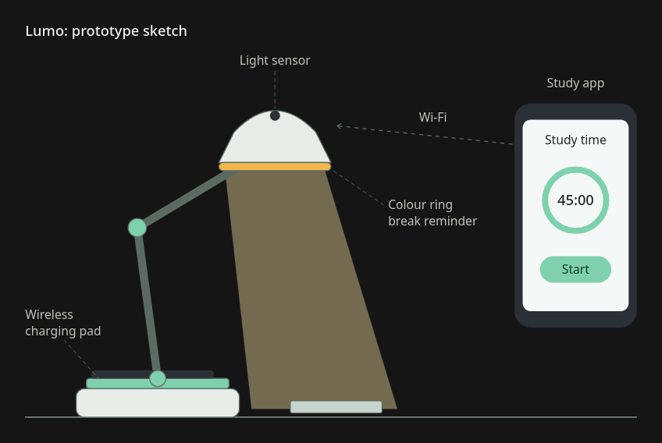

Product plan
Product name: Lumo
What is it? A smart desk lamp that looks after your eyes, your battery and your concentration at the same time.
The problem it solves: Most of us have been in the situation where we sit down to study "for an hour" and look up three hours later with a headache and a dead phone. Poor lighting makes us tired faster, and nothing tells us when to stop. Lumo deals with both problems.
How it works:
- A built-in sensor measures the natural light in the room and adjusts the brightness and colour temperature automatically.
- Its artificial intelligence learns your study habits. When you have been working for too long without a break, the colour ring at the bottom of the shade changes gently from white to amber, like a polite nudge.
- The base doubles as a wireless charging pad, so your phone charges while you study, and it stays out of your hands.
- A companion app, connected via Wi-Fi, lets you set study sessions and track your progress.
Target users: University students, remote workers and gamers, basically anyone who spends long hours at a desk.
Price and colours: 79€, available in white, black and mint green.
Technology words I will use: Sensor, artificial intelligence, wireless charging, Wi-Fi, app, hardware, software.
And one more thing: Lumo tells you when you finish the timer for the study session.

